|  |
| --- |
| CPSC 403 – Software Development in Teams and organizations |
| Iteration 1 - Report |
| Hospital Management System |
|  |
| **Prepared by James Bertram, Thomas Frampton, Ekaterina Grekova, Matthew Jones, Andrew Midwinter, Mark Mullen** |
| **2/24/2012** |

|  |
| --- |
|  |

Contents

Summary 3

Domain Model 3

Stories 3

Updated Tentative Release Plan 4

Deliverables of Iteration 1 4

Work Distribution 4

Appendix A – Diagrams 5

Appendix B – Story Board 6

# Table of Figures

Figure 1. Diagram 5

Figure 2. Our story board as of February 24, 2012 6

# Summary

# Domain Model

Various diagrams were created during initial design to help visualizing and clarifying main requirements of HMS. Our initial design underwent changes during implementation process. During discussions, we came to agreement that a simpler architecture can be developed. That architecture is understood by everyone in the team, and it allows adding new features, testing implemented coded and debugging in an easy manner. The supplementary diagrams were updated and can be found in Appendix A.

# Stories

The identified stories remain the same as in Iteration 0. Below are the stories, which are sorted by their priority. A picture of our story board is in Appendix B.

**Priority 1:**

1.1: Assigning patients to rooms:

This feature allows nurses or administrators to assign patients to specific rooms.

1.2: Tracking Patient Information:

This feature allows administrators to enter, edit, and view information about patients.

1.3: Tracking Bed/Room availability:

This feature keeps track of which beds and rooms are currently available, and which are currently occupied.

1.4: Assigning Nurses to Wards:

This feature allows administrators to assign nurses to wards.

1.5: Encrypting of Patient Information:

Patient information will be encrypted for security.

**Priority 2:**

2.1: Tracking Nurse Information:

Doctors and head nurses can enter, edit nurses' information.

**Priority 3:**

3.1: Placing Patients in a Priority Queue:

Patients will be placed in a priority queue to order them by the severity of their illness or injury.

**Priority 4:**

4.1: Searching for Patients:

Nurses and Doctors can search for information about a specific patient.

**Priority 5:**

5.1: Scheduling Nurses:

Administrators can create schedules to assign nurses to shifts.

# Updated Tentative Release Plan

However, the tentative release plan has changed. The implementation of the base architecture required more time than we estimated initially.

**Tentative Release Plan:**

**Iteration 1:**

Build base architecture

Implemented feature 1.2 using TDD

**Iteration 2:**

Implement features 1.1, 1.3, 1.4, 2.1 and 3.1.

**Iteration 3**:

Implement features 1.5, 4.1 and 5.1

# Deliverables of Iteration 1

# Work Distribution

# Appendix A – Diagrams

Figure . Diagram

# Appendix B – Story Board

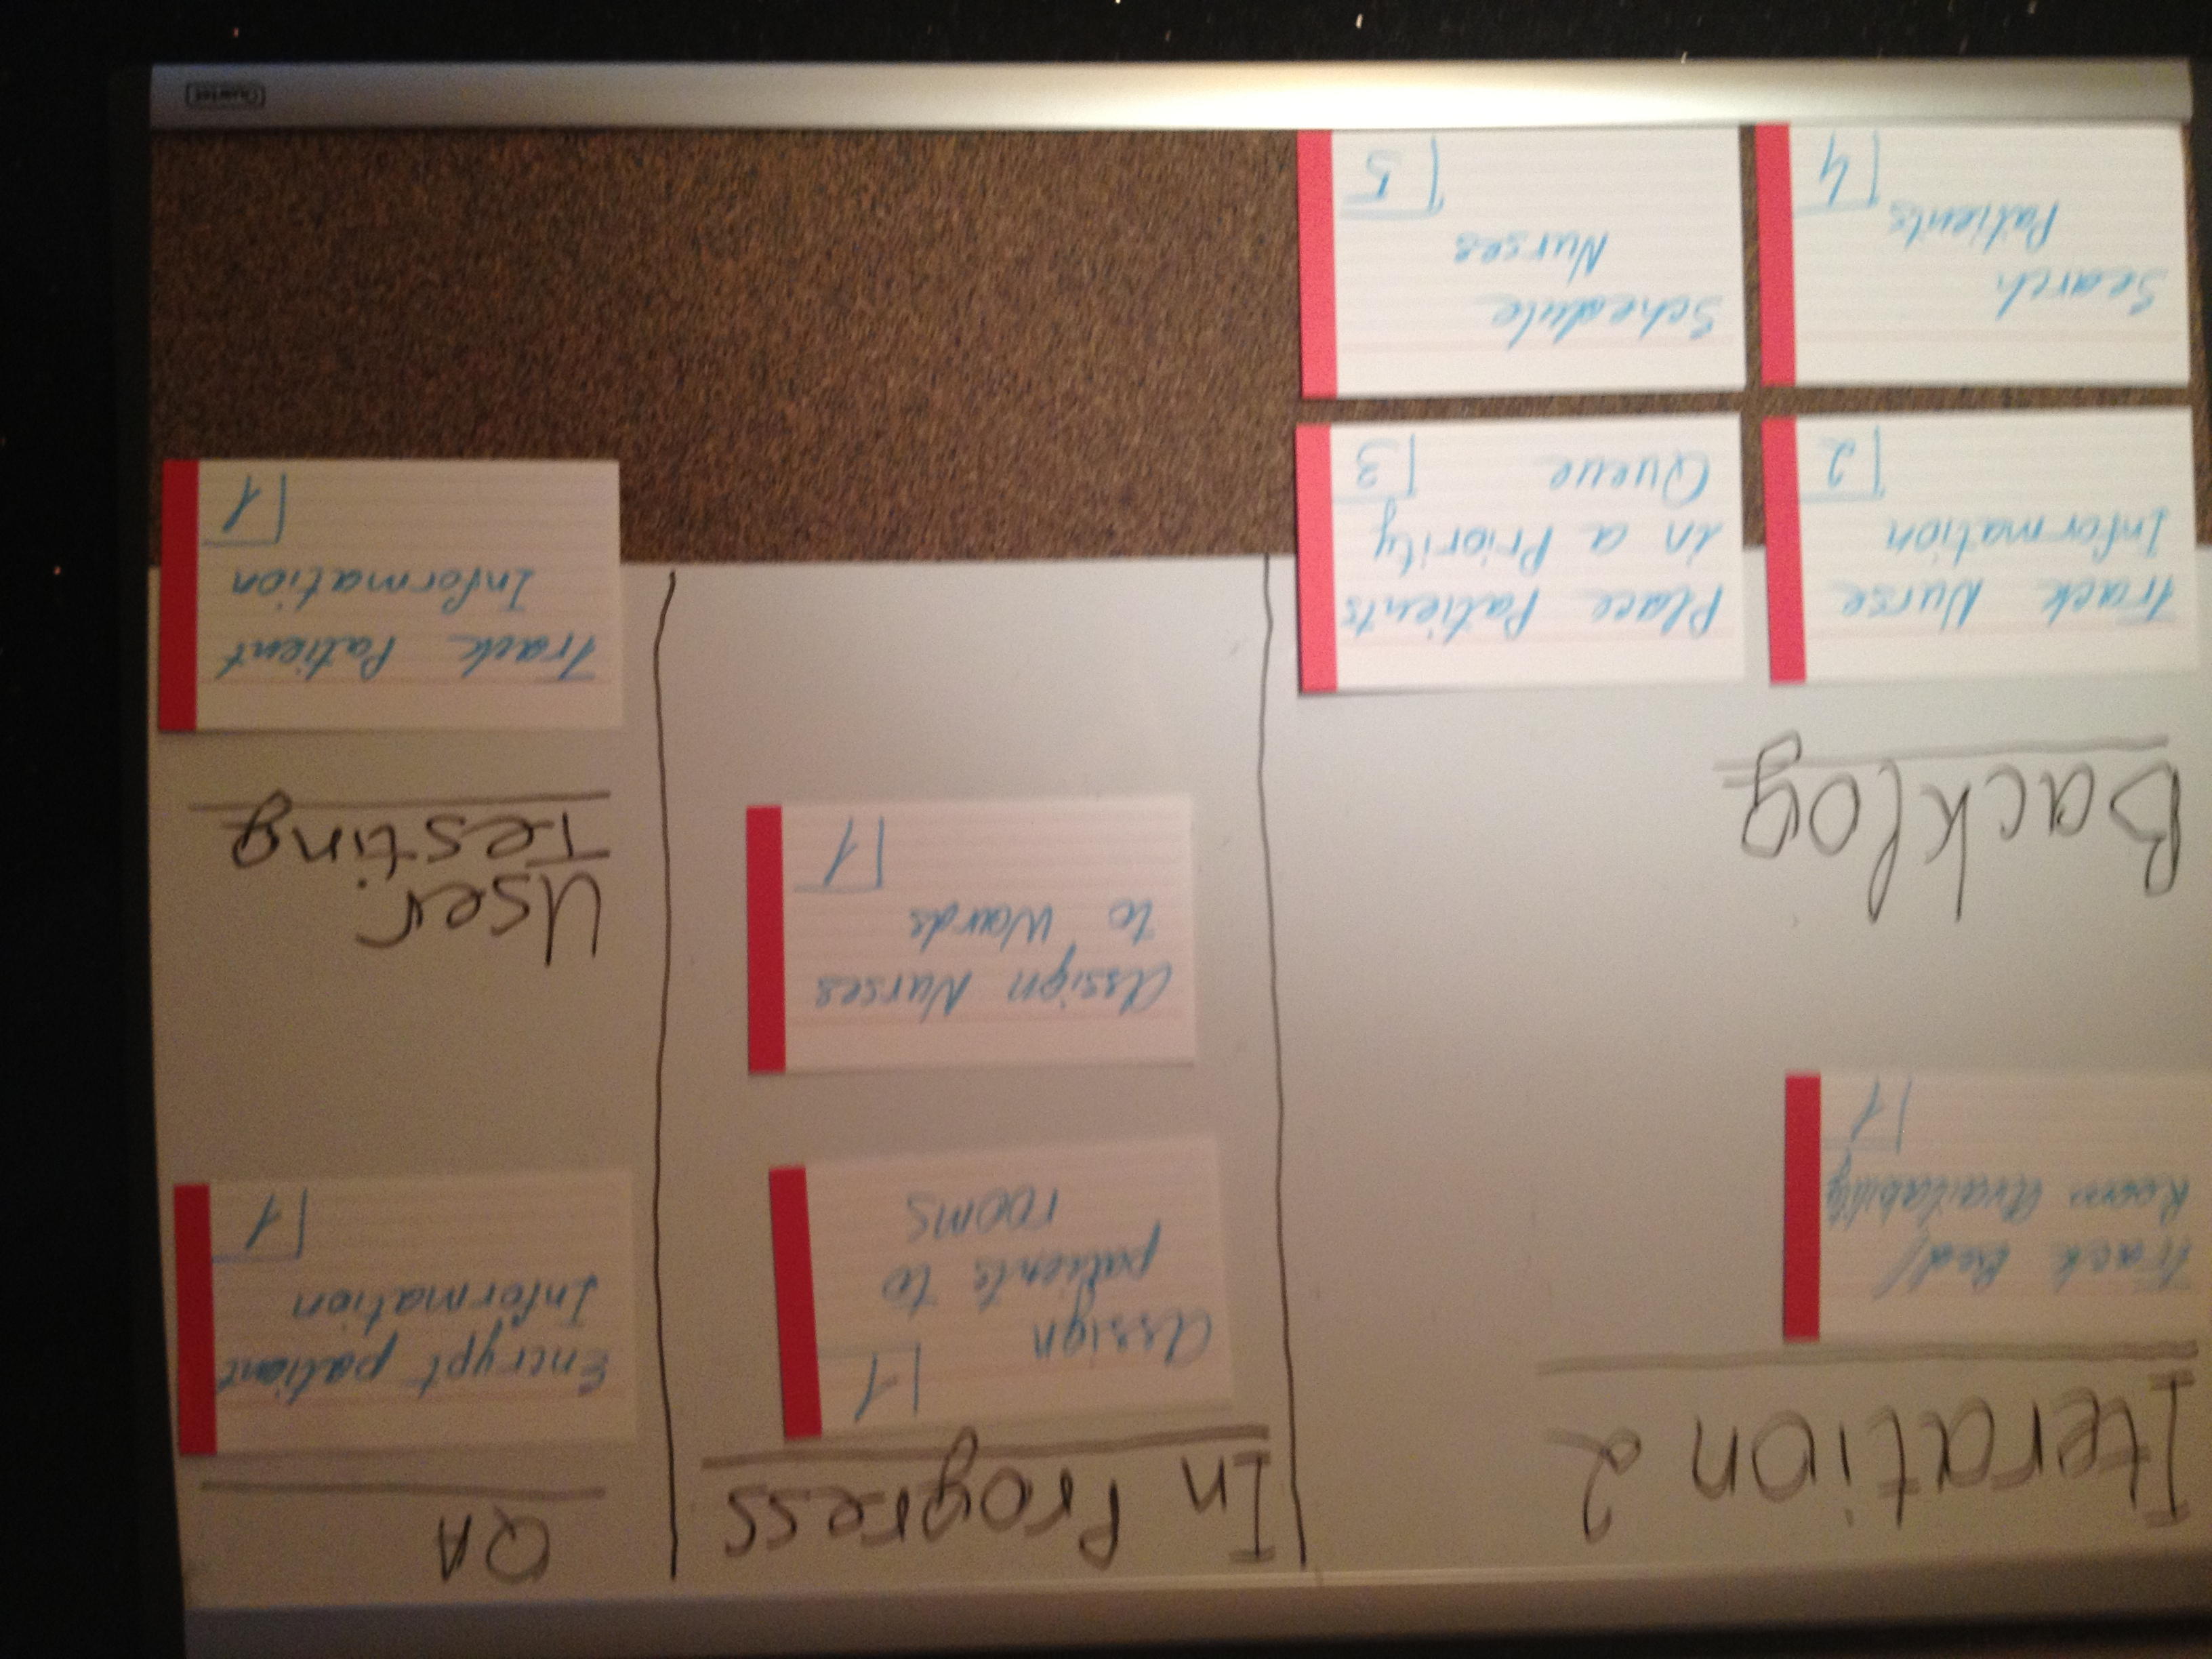

Additional details about the feature and to whom it was assigned are written on the back of the card.

Figure 2. Our story board as of February 24, 2012